**Development of Throwable Ball Camera**

**Principal Investigator:** Dr Amer Sohail Kashif

**Industrial Collaborator:** M/S Octathorn, Islamabad

**Estimated Duration:** 18 months

**Estimated Cost:** PKR 5 Mn

**Extended Abstract:**

A spherical imaging system capable of capturing 360⁰ Field of View (FOV) will be designed with an objective to take panoramic pictures of area under projection. Several models of Throwable Ball Cameras have been developed in the 2010s with aim to attain situational awareness of the area that is otherwise inaccessible. This technology can prove to be a force multiplier in the modern battlefield scenario, especially in covert operations. Detailed research is required to develop a proof-of-concept device, using adequate number of open-source cameras such as Arducam, OV7670, OV2640 or high end industrial uEye+ iDS, GmbH, Germany to be able to capture 360⁰ panoramic view. Camera selection is the 1st challenge, as exact number of cameras required to cover whole 360⁰ can only be determined depending upon camera specifications such as resolution, aperture, frame rate, shutter speed and transfer speed, etc. After selecting the camera, the FOV of a single lens will be known and total number required can be calculated.

Inertial Sensor Module IMU unit will be incorporated containing accelerometer and gyroscope through which it can be identified when the ball has reached its maximum elevation and must be dropped to attain most stable equilibrium, so that it can capture motion-blur free images. Other option is to design a mechanical enclosure to stabilize the internal structure such that there is minimal or no movement inside the ball when rotating e.g gyro stabilization or gimbal.

The next challenge is to capture images from all imaging devices simultaneously. Using multiple controllers may not a feasible option. Multiplexing all cameras with a single micro controller will lead to inadequate latency capturing distort images. Using a microprocessor with multi-threaded application capable of communicating with multiple cameras simultaneously can be a feasible option. Alternatively, FPGA can be used to develop a customized hardware solution, as shown in Figure 1.

**Figure 1: Conceptual schematic describing functioning and transfer protocol of 360-degree panoramic image capturing system**

Images taken by cameras will be transferred to end device that can be a PC or a smart phone using Wi-Fi over a TCP connection. The ball can act as a TCP server, acting as an access point. Host will connect to the device using configured access point credentials.

This panoramic imaging system will be battery powered so power efficiency will also be an area of concern as significantly high number of cameras will make it power hungry. On the software side, image stitching algorithm will be developed that will identify relative position of each camera and join the images to create a 360⁰ view. Creating an immersive 360⁰ view in smart phone is major challenge at 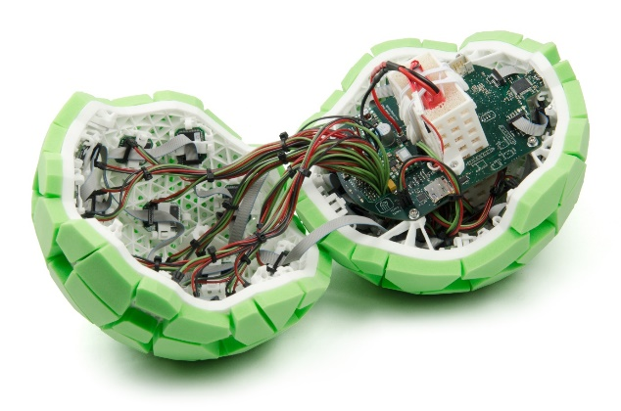software side and may be kept flexible.

**Figure 2: Projected shape of the developed product (left) and cutout model of internal circuitry (right)**

Designing a compact, lightweight, rugged, shock proof, thermal & water-resistant mechanical enclosure as shown in Figure 2 will be another major challenge. Additionally, cameras can be equipped with infrared LEDs making the whole system capable of night vision. **Our previous experience of developing a system containing 3 x Arducam connected with a Node MCU and transmitting images to a locally hosted webpage will prove to be a bench mark in developing this system.**